

HOSPITAL MANAGEMENT SYSTEM

CSE3002 – INTERNET & WEB PROGRAMMING

J COMPONENT PROJECT DOCUMENT

FALL 2019 - 2020

GROUP PROJECT

1. 17BCE0188 Thanushri R

2. 17BCI0196 Kavishna Sekar

UNDER THE GUIDENCE OF

PROF. NAVEEN KUMAR N

SCOPE



**School of Computer Science and Engineering**

**DECLARATION**

We hereby declare that the J Component project entitled **“Hospital Management System”** submitted by us to the School of Computer Science and Engineering, VIT University, Vellore-14 in partial fulfillment of the requirements for the **Internet and Web Programming (CSE3002)** course,is a record of bonafide work carried out by us under the supervision of **Naveen Kumar N, Assistant Professor (Sr).** We further declare that the work reported in this project has not been submitted and will not be submitted, either in part or in full, for the award of any other degree or diploma of this institute or of any other institute or university.

Reg.No: 17BCE0188 Reg.No: 17BCI0196

Name : Thanushri R Name : Kavishna Sekar

**Chapter Title Page**

Title Page i

Declaration ii

Table of Contents iii

List of Figures iv

Abstract v

1. Introduction

1.1. Aim

1.2. Objective

1. System Requirements
2. Solution for existing problems
3. Screenshots
4. Conclusion

**List of figures**

|  |  |  |
| --- | --- | --- |
| **Figure No** | **Figure Caption** | **Page No** |
|  | Patient session log |  |
|  | Doctor session log |  |
|  | Doctor log after pressing delete button |  |
|  | Home page |  |
|  | Health A-Z |  |
|  | Health A-Z after hovering body parts |  |
|  | Home page of website |  |
|  | About page of website |  |
|  | About page of website (Scrolled down) |  |
|  | Contact page of website |  |
|  | Contact page of website (scrolled down) |  |
|  | Contact page details in database |  |
|  | Patient login |  |
|  | Patient home |  |
|  | Book appointments in patient module |  |
|  | Appointment history in patient module |  |
|  | Patient profile |  |
|  | Patient edit profile |  |
|  | Patient edit profile (scrolled down) |  |
|  | Patient signup |  |
|  | Patient signup (scrolled down) |  |
|  | Doctor login |  |
|  | Doctor home |  |
|  | Doctor’s appointments |  |
|  | View his patients |  |
|  | View his patient’s details |  |
|  | Doctor profile |  |
|  | Doctor edit profile |  |
|  | Doctor edit profile (scrolled down) |  |
|  | Doctor signup |  |
|  | Doctor signup (Scrolled down) |  |
|  | Admin login |  |
|  | Admin home page |  |
|  | Manage patients |  |
|  | Add doctor |  |
|  | Add doctor (Scrolled down) |  |
|  | Manage doctors |  |
|  | Manage specialization |  |
|  | Manage specialization after adding a new one |  |

**Abstract**

The main intention of introducing this system is to reduce the manual work at Health center counters. Every sort of task is performed by the system, such as registering different types of persons (i.e. employees, students and others), making changes and appointments etc. reducing much paper work and burden of file storage. Also, the latest information is right available for the officials and executives wherever they require.

There are a lot of benefits to the Health center by placing the system at their  
registration and at drug store office. At the same time the patients are also benefited  
using this system. They can get the work done within no time.  
Using the system is as simple as using the personal computer. Since end user computing is developing in our country, it is beneficial to both the hospital and the patients. Every step is clearly defined and help is provided throughout the application to the user. Even the exceptions are handled well to avoid confusion.

The heath center can get much out of the system. The system is used to enter the  
patient details and to enter the details about the hospital and the details  
about the in-patient and out-patient in detail and about the reports of the patients.  
This system represents the patient by the id number and this is main criteria how  
the patient is provided by the free services.

1. **Introduction**
   1. **Aim**

The Hospital Management System (HMS) is designed for Any Hospital to replace their existing manual, paper-based system. The new system is to control the following information; patient and doctor information, patient invoices and making appointments. These services are to be provided in an efficient, cost effective manner, with the goal of reducing the time and resources currently required for such tasks.

* 1. **Objective**

Hospitals currently use a manual system for the management and maintenance of critical information. The current system requires numerous paper forms, with data stores spread throughout the hospital management infrastructure. Often information (on forms) is incomplete, or does not follow management standards. Forms are often lost in transit between departments requiring a comprehensive auditing process to ensure that no vital information is lost. Multiple copies of the same information exist in the hospital and may lead to inconsistencies in data in various data stores.

1. **System Requirements**

Database: Apache, mysql from phpMyAdmin using the xampp server

Browser: Google chrome, Firefox browser

Operating system: Windows 10

Nodejs libraries with npm and mysql module

1. **Solution for Existing problems**

**3.1. Solution-1**

* + 1. **Problem description and its Solution**

The session logs contain records that capture user activities. These logs are stored in an internal MySQL database. A user session begins when a user logs in and ends when a user logs out. User sessions are hosted by the server the user logs in to. The user name and password they type determine the type of user they are. Once the patient or the doctor logs in, the login date and time is stored in the patientlog or doctorlog table and those values are being displayed in the table under the admin module. Delete all logs button is used to delete the patient or doctor logs which are stored in the table.

* + 1. **Sample code**

Code to save the login date and time in the patient log table:

<?php

session_start();

include('connection.php');

$username=$_POST['Username'];

$password=$_POST['Password'];

$sql="SELECT pmail,ppass,pno from patient";

$result = mysqli_query($connect,$sql);

while($row = mysqli_fetch_assoc($result))

{

if($row['pmail']==$username)

{

if($row['ppass']==$password)

{

$un=$row['pmail'];

$_SESSION['patientun']=$un;

$res=$row['pno'];

$_SESSION['pid']=$res;

$uip=$_SERVER['REMOTE_ADDR'];

$action="Login";

mysqli_query($connect,"insert into patientlog(patientid,username,userip,action) values('".$_SESSION['pid']."','".$_SESSION['patientun']."','$uip','$action')");

header("Location:patienthome.html");

}

else

{

echo '<script language="javascript">alert("The username/password is not correct");window.location.href="patientlogin.html";</script>';

}

}

}

mysqli_close($connect);

?>

Code to display the session logs in a table format:

<?php

include("connection.php");

$query=mysqli_query($connect,"select * from patientlog");

$cnt=1;

while($row=mysqli_fetch_array($query))

{

?>

<tr>

<td><?php echo $cnt;?></td>

<td><?php echo $row['patientid'];?></td>

<td><?php echo $row['username'];?></td>

<td><?php echo $row['userip'];?></td>

<td><?php echo $row['action'];?></td>

<td><?php echo $row['actiontime'];?></td>

</tr>

<?php $cnt=$cnt+1;

} ?>

* + 1. **Screenshot for Patient and Doctor session logs**

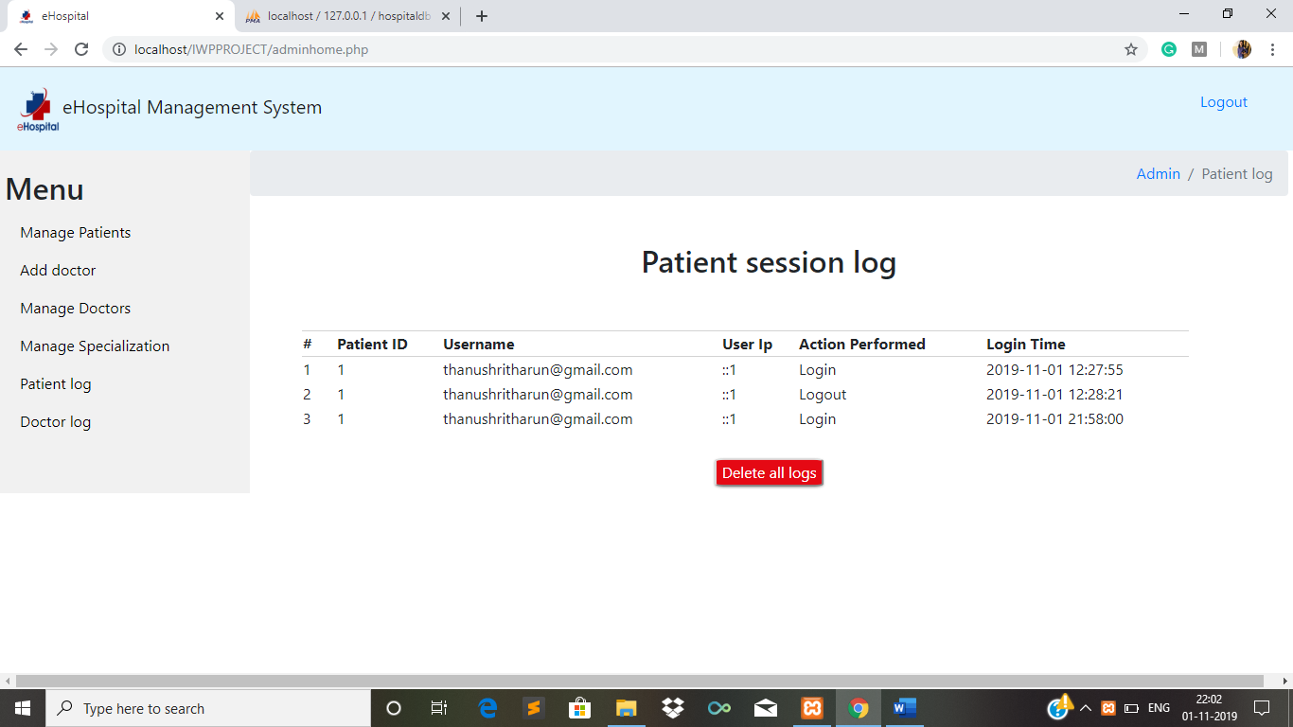

Figure 1: Patient session log

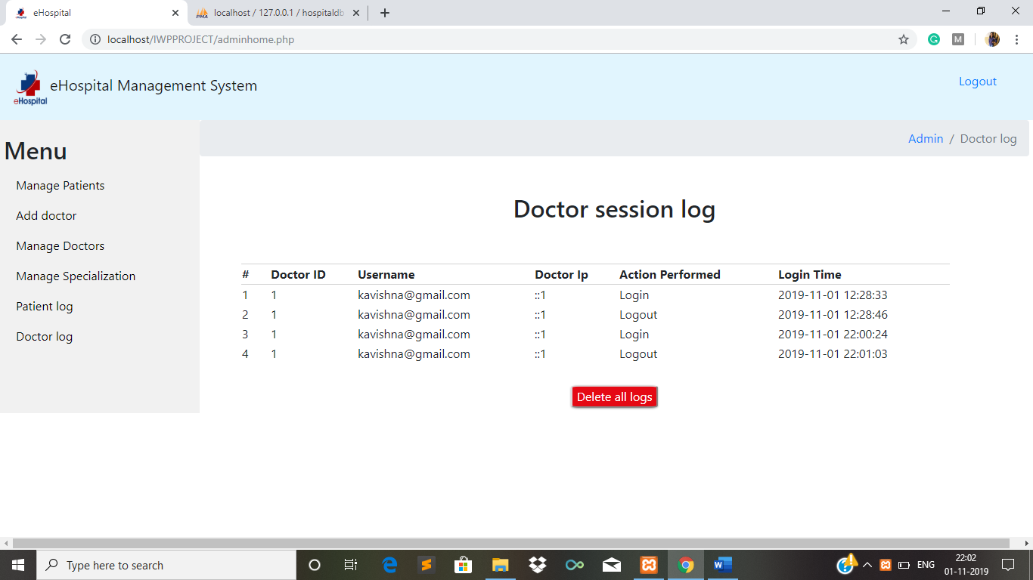

Figure 2: Doctor session log

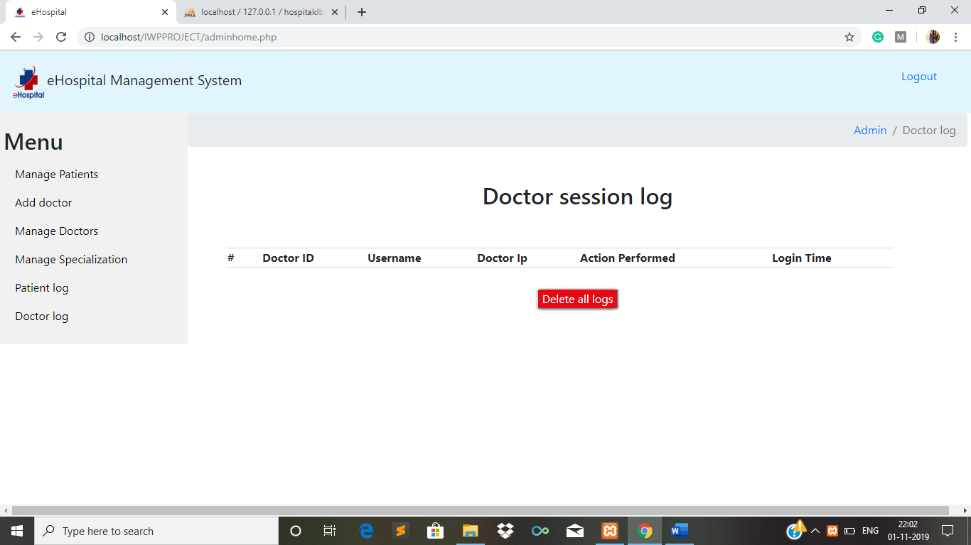

Figure 3: Doctor log after pressing delete button

* 1. **Solution-2**
     1. **Problem description and its Solution**

Appointments can be made by hovering on the different parts of the human body which is displayed which gives the list of ailments corresponding to that body part. Based on these, the patients can make appointments.

* + 1. **Sample code**

<html>

<head>

<script>

function onfunction1() {

var slides = ["Central Auditory Processing Disorder (CAPD)","Ear, Nose & Throat (Otorhinolaryngology)","Hearing Loss Hormone Disorder (Endocrinology)","Tinnitus"];

var str = '<h3>Conditions and diseases related to Ear</h3><hr><ul>'

slides.forEach(function(slide) {

str += '<li>'+ slide + '</li>';

});

str += '</ul>';

document.getElementById("show").innerHTML = str;

}

function onfunction() {

var slides = ["Attention Deficit Hyperactivity Disorder (ADHD)","Brain Aneurysm","Brain Tumour","Cancer (Oncology)","Computerised Tomography (CT) Scan","Dementia","Digital Subtraction Angiography (DSA)","Electromyogram (EMG)","Epilepsy","Gamma Knife Radiosurgery","Hormone Disorder (Endocrinology)","Neuro-Rehabilitation Programme","Parkinson’s Disease","PET-MRI Scan","Positron Emission Tomography (PET) Scan"]

var str = '<h3>Conditions and diseases related to Brain</h3><hr><ul>'

slides.forEach(function(slide) {

str += '<li>'+ slide + '</li>';

});

str += '</ul>';

document.getElementById("show").innerHTML = str;

}

function onfunction2(){

var slides = ["Cancer (Oncology)","Ear, Nose & Throat (Otorhinolaryngology)","Hormone Disorder (Endocrinology)","Nasopharynx (Nose) Cancer Sinusitis","Surgical-Functional Endoscopic Sinus Surgery (FESS)"];

var str = '<h3>Conditions and diseases related to Nose</h3><hr><ul>'

slides.forEach(function(slide) {

str += '<li>'+ slide + '</li>';

});

str += '</ul>';

document.getElementById("show").innerHTML = str;

}

function onfunction4(){

var slides = ["Ear, Nose & Throat (Otorhinolaryngology)","General Surgery","Head and Neck Conditions","Hormone Disorder (Endocrinology)","Laryngovideostroboscopy","Larynx (Voice Box) Cancer","Thyroid Disorder","Tonsillitis","Torticollis (Wry Neck)"];

var str = '<h3>Conditions and diseases related to Neck</h3><hr><ul>'

slides.forEach(function(slide) {

str += '<li>'+ slide + '</li>';

});

str += '</ul>';

document.getElementById("show").innerHTML = str;

}

function onfunction3(){

var slides = ["Cancer (Oncology)","Cataract","Corneal Transplant (Artificial and Conventional)","Eyes (Ophthalmology)","Glaucoma","Macular Degeneration","Neuro-ophthalmology Disorders","Refractive Surgery (LASIK)"];

var str = '<h3>Conditions and diseases related to Eye</h3><hr><ul>';

slides.forEach(function(slide) {

str += '<li>'+ slide + '</li>';

});

str += '</ul>';

document.getElementById("show").innerHTML = str;

}

</script>

</head>

<body>

<img src="body.jpg" usemap="#image-map">

<map name="image-map">

<area target="" alt="brain" title="brain" href="#" coords="262,20,10" shape="circle" onmouseover="onfunction()">

<area target="" alt="ear" title="ear" href="" coords="292,48,10" shape="circle" onmouseover="onfunction1()">

<area target="" alt="nose" title="nose" href="" coords="263,46,10" shape="circle" onmouseover="onfunction2()">

<area target="" alt="eye" title="eye" href="" coords="252,37,10" shape="circle" onmouseover="onfunction3()">

<area target="" alt="neck" title="neck" href="" coords="265,89,10" shape="circle" onmouseover="onfunction4()">

<area target="" alt="shoulder" title="shoulder" href="" coords="319,106,10" shape="circle" onmouseover="onfunction5()">

</map></body></html>

* + 1. **Sample Screenshots for Health A-Z**

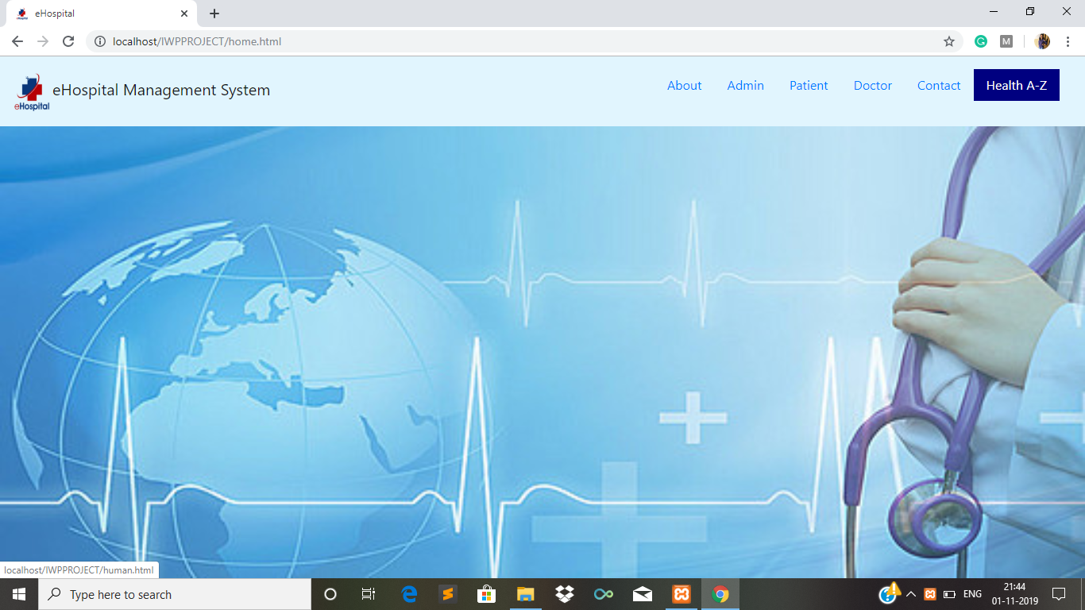

Figure 4: Home page

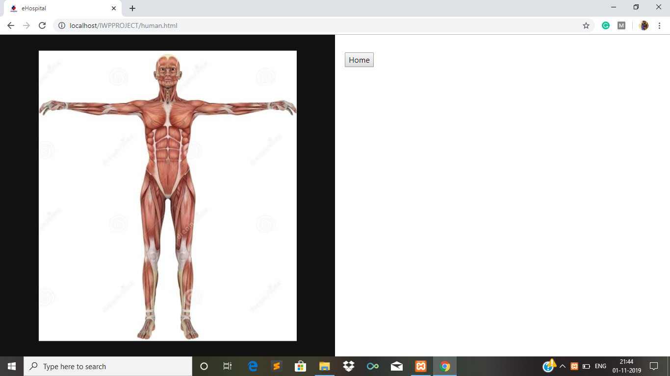

Figure 5: Health A-Z

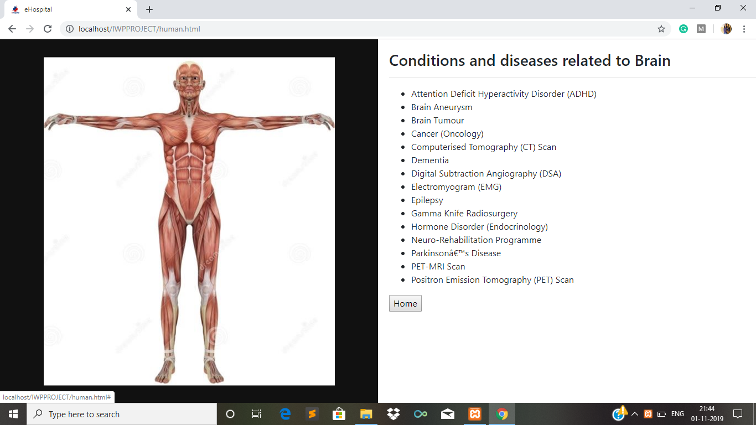

Figure 6: Health A-Z after hovering body parts

* 1. **Solution-3**
     1. **Problem description and its Solution**
     2. **Sample code**
     3. **Sample Screenshot**
  2. **Solution-4**
     1. **Problem description and its Solution**
     2. **Sample code**
     3. **Sample Screenshot**
  3. **Solution-5**
     1. **Problem description and its Solution**
     2. **Sample code**
     3. **Sample Screenshot**

**4. Screenshots**

**4.1. Home page**

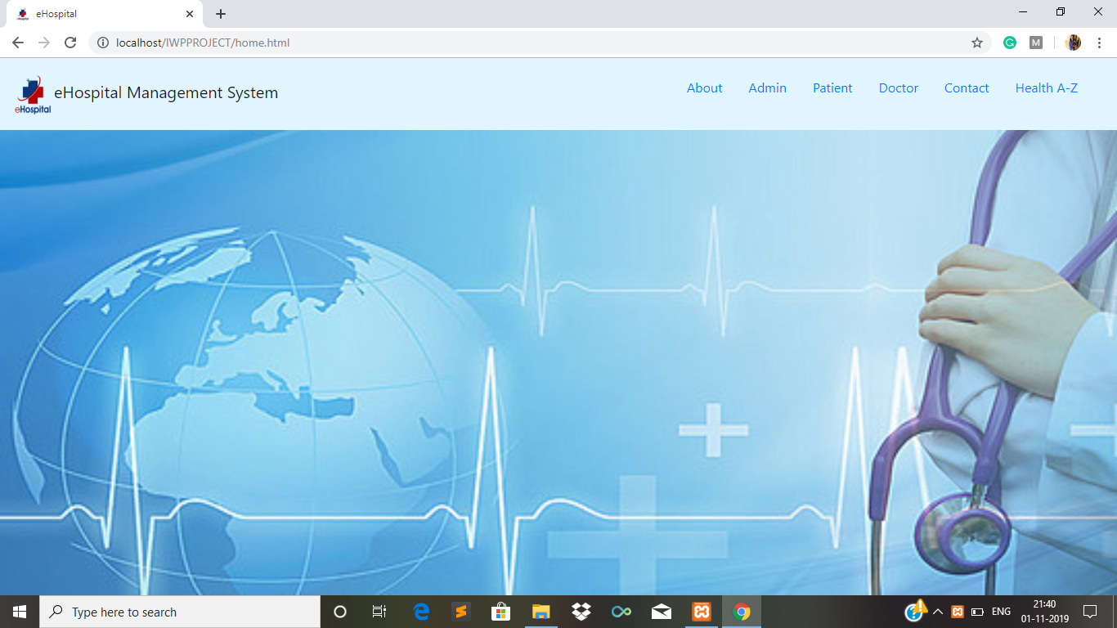

Figure 7: Home page of website

**4.2. About page**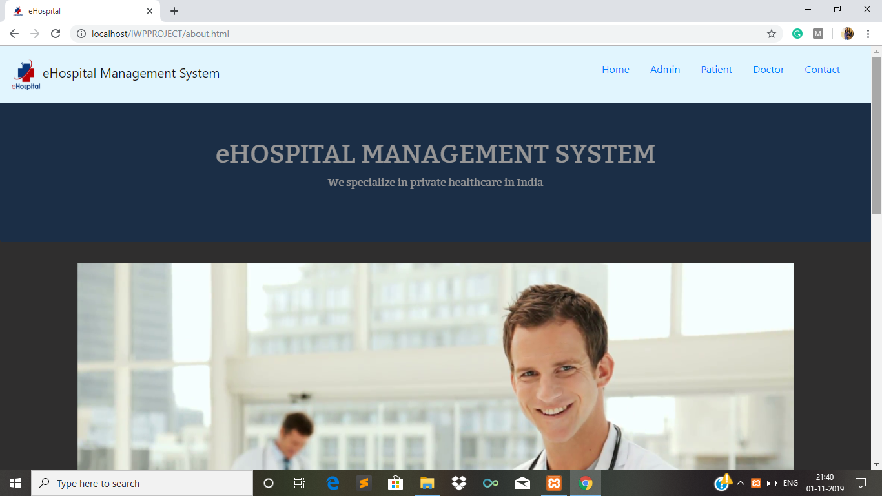

Figure 8: About page of website

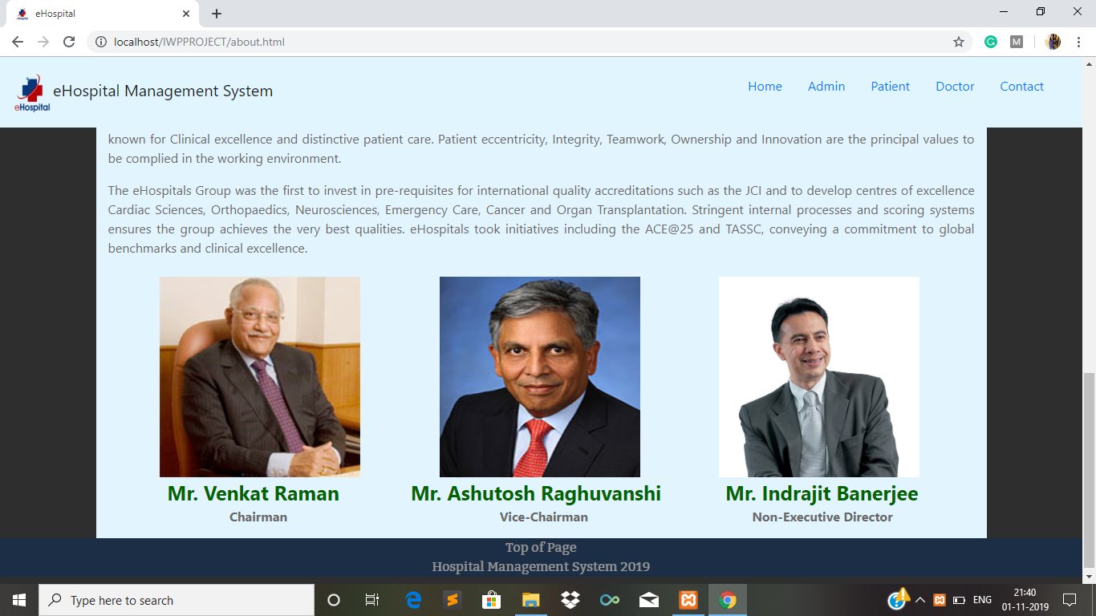

Figure 9: About page of website (Scrolled down)

**4.3. Contact page**

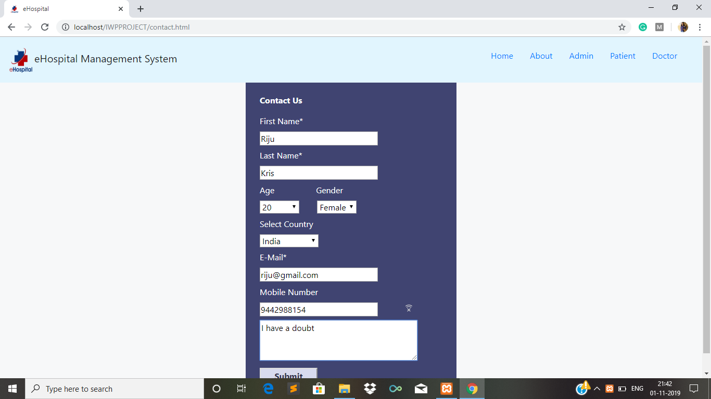

Figure 10: Contact page of website

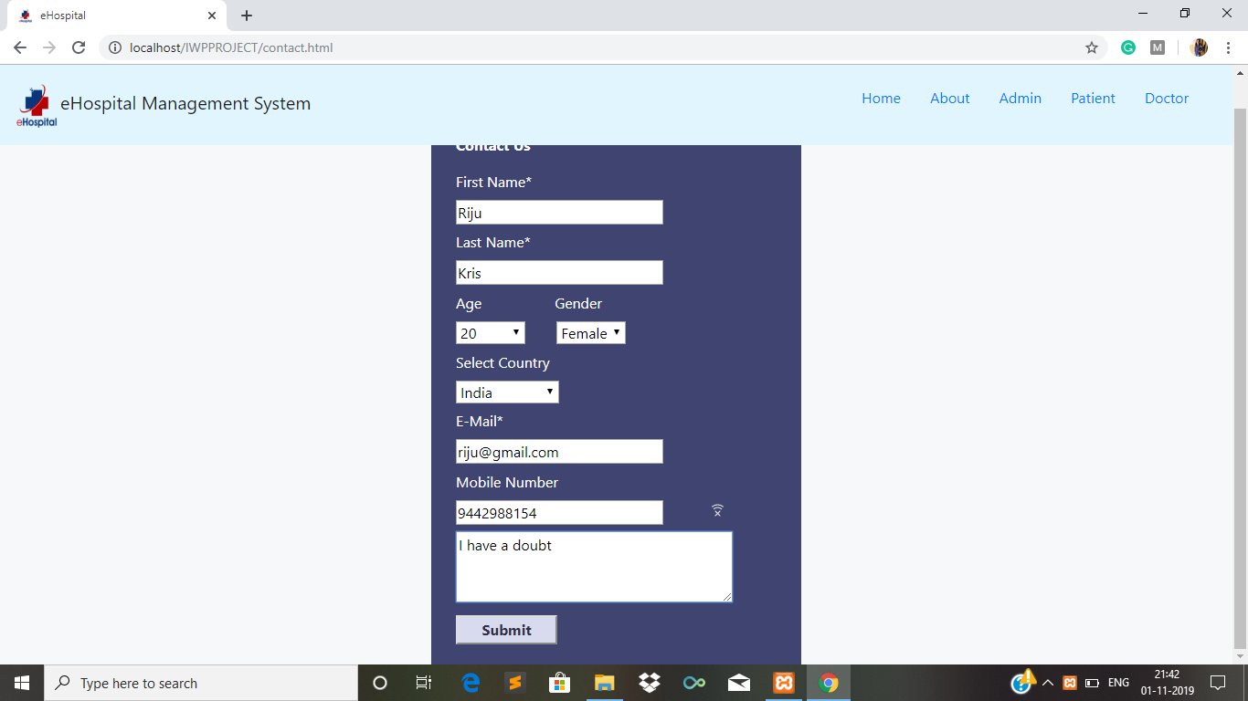

Figure 11: Contact page of website (scrolled down)

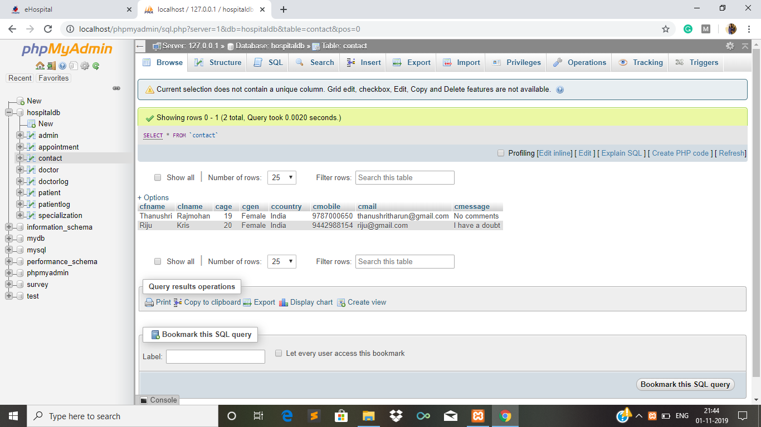

Figure 12: Contact page details in database

**4.4. Patient module**

**4.4.1. Patient login**

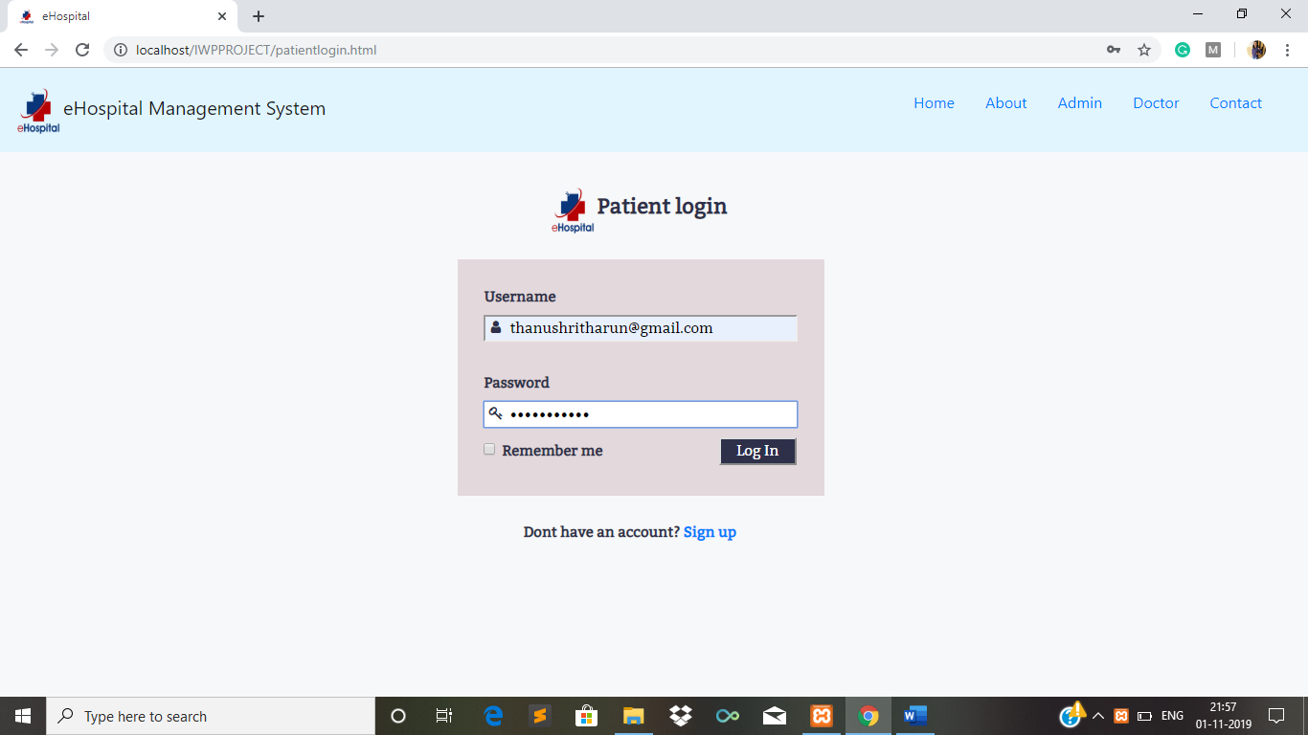

Figure 13: Patient login

**4.4.2. Patient Home page**

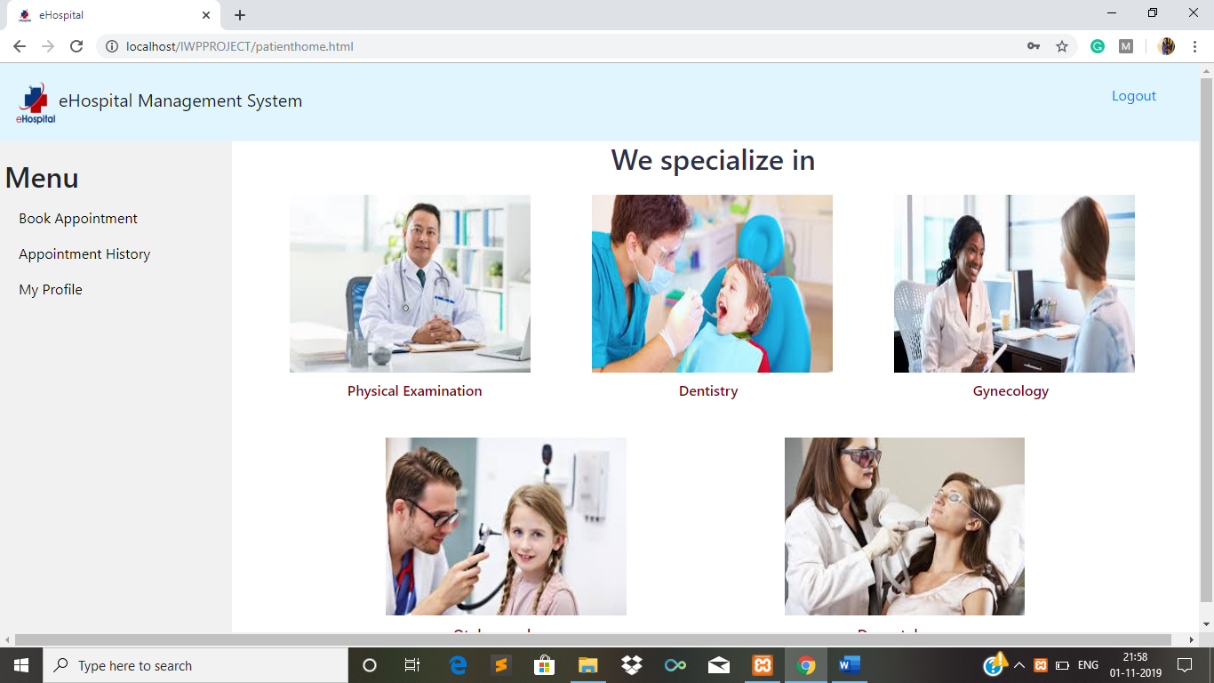

Figure 14: Patient Home

**4.4.3. Book Appointment**

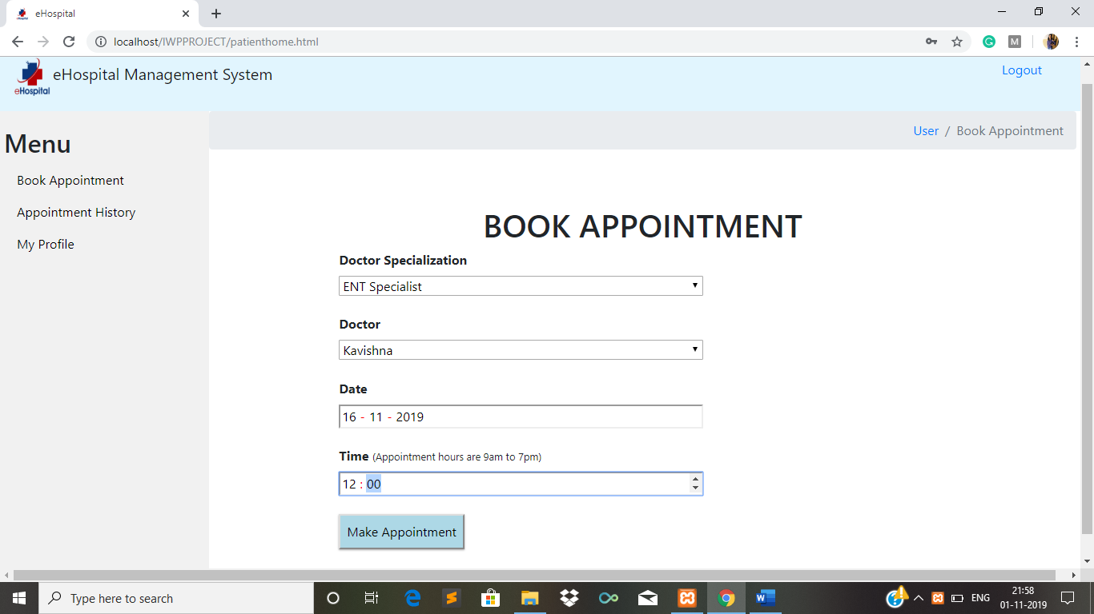

Figure 15: Book appointments in patient module

**4.4.4. Appointment History**

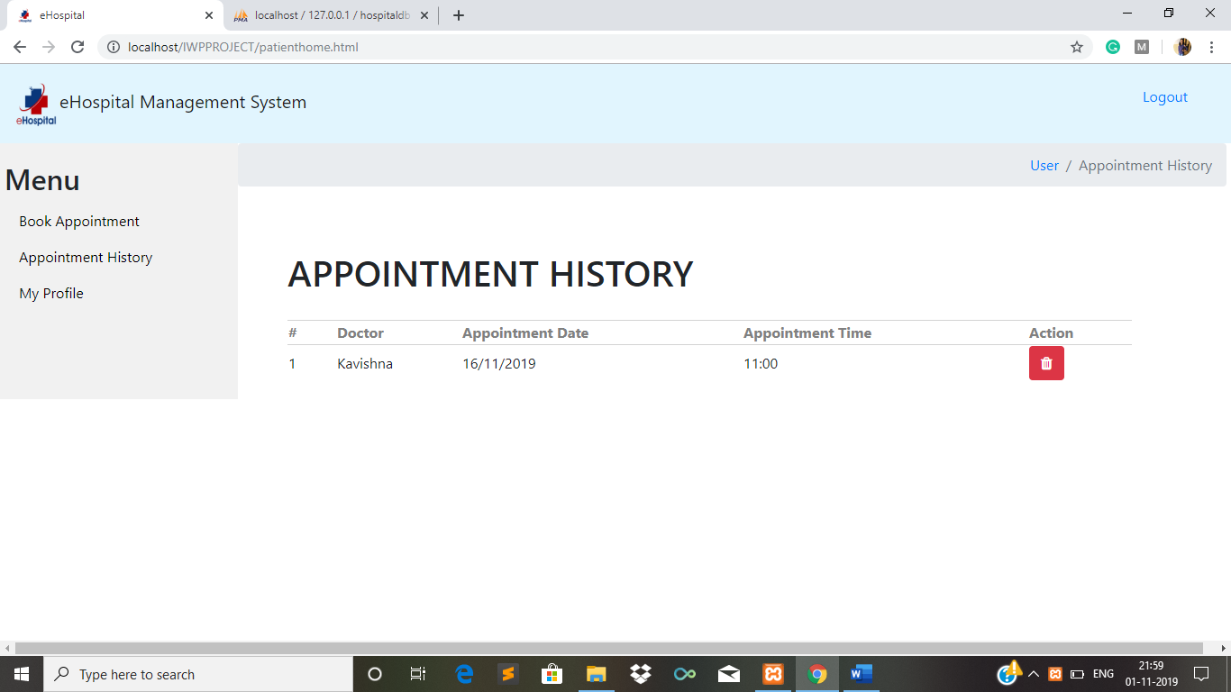

Figure 16: Appointment history in patient module

**4.4.5. Patient profile**

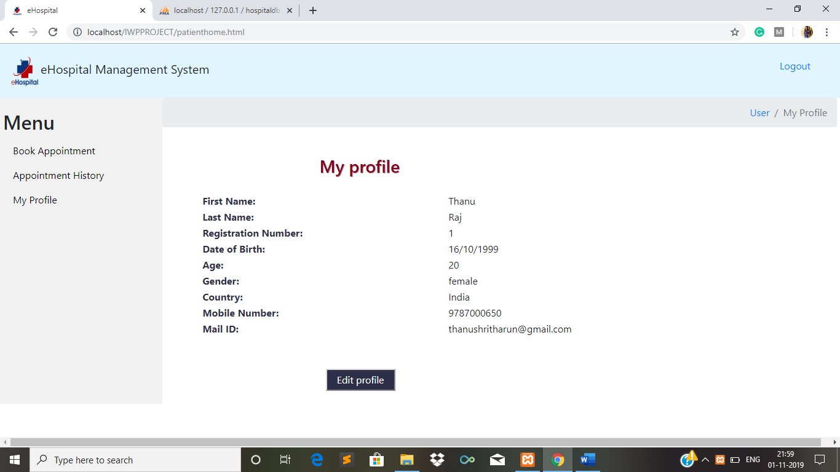

Figure 17: Patient profile

**4.4.6. Patient edit profile**

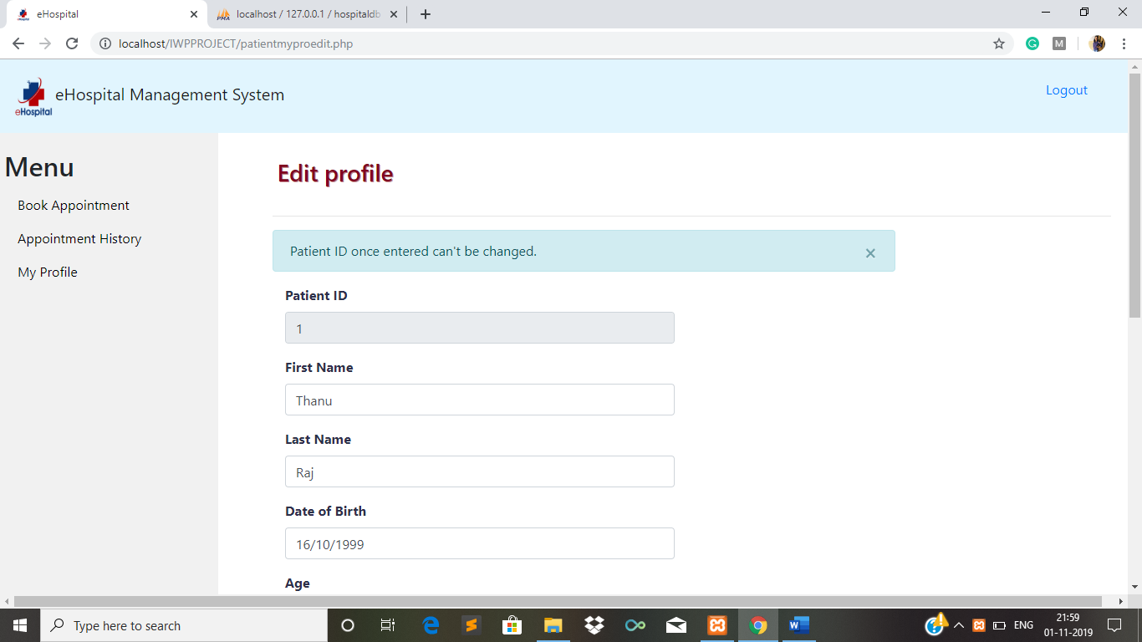

Figure 18: Patient edit profile

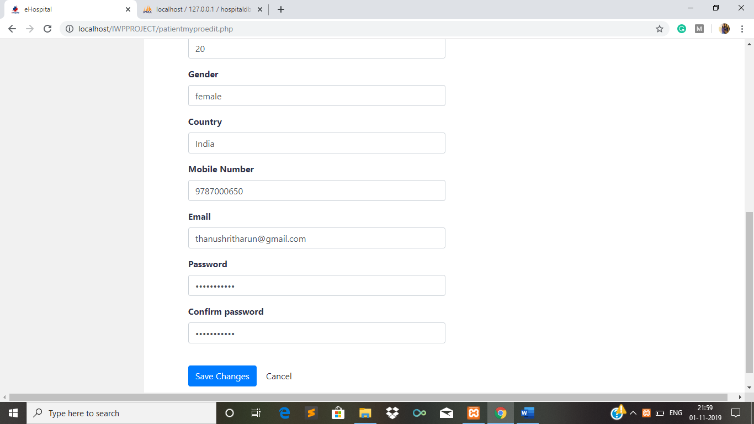

Figure 19: Patient edit profile (scrolled down)

**4.4.7. Patient sign up**

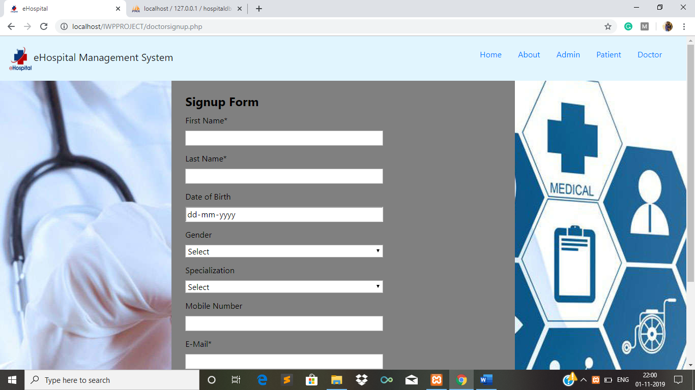

Figure 20: Patient signup

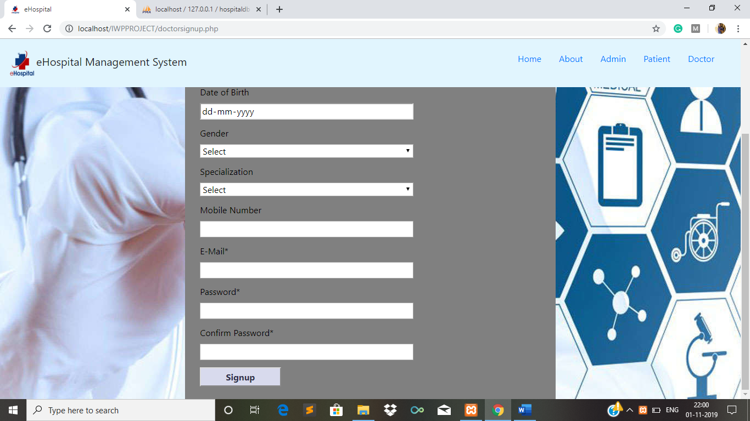

Figure 21: Patient signup (scrolled down)

**4.5. Doctor Module**

**4.5.1. Doctor login**

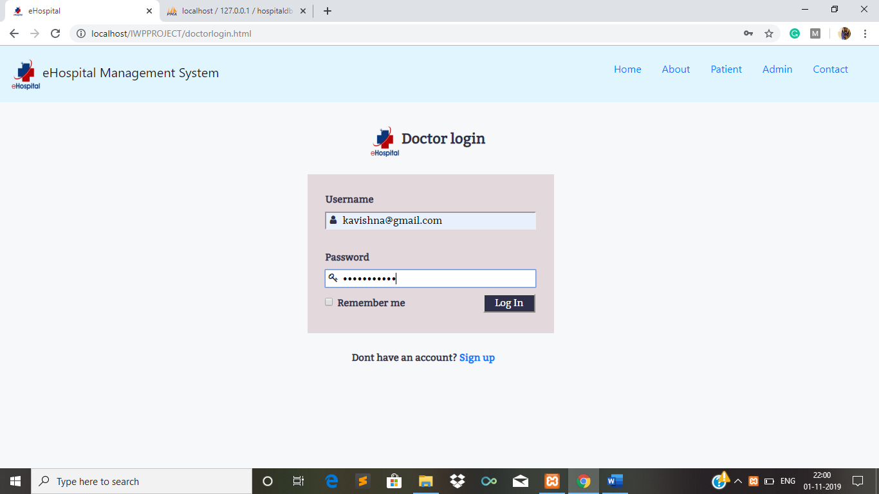

Figure 22: Doctor login

**4.5.2. Doctor home page**

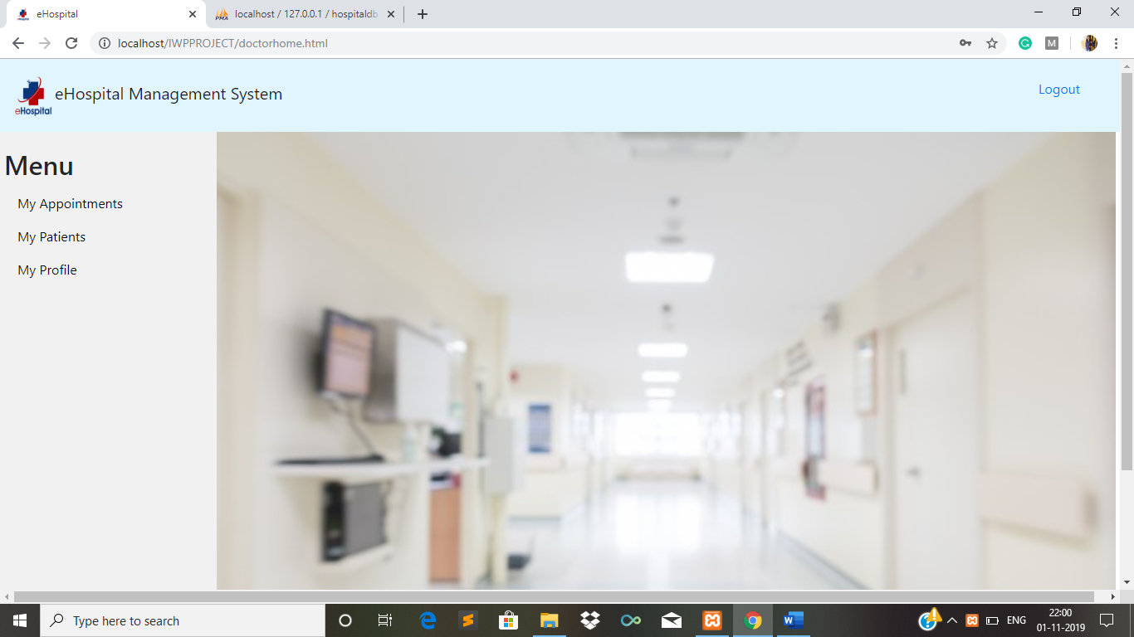

Figure 23: Doctor home

**4.5.3. Doctor’s appointments**

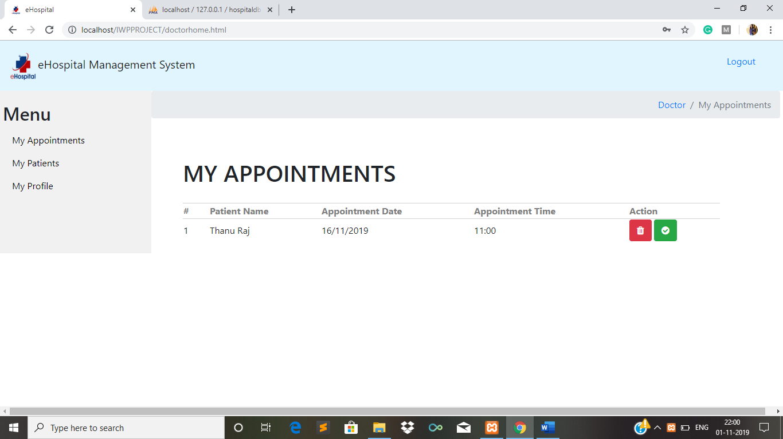

Figure 24: Doctor’s appointments

**4.5.4. View patients and their details**

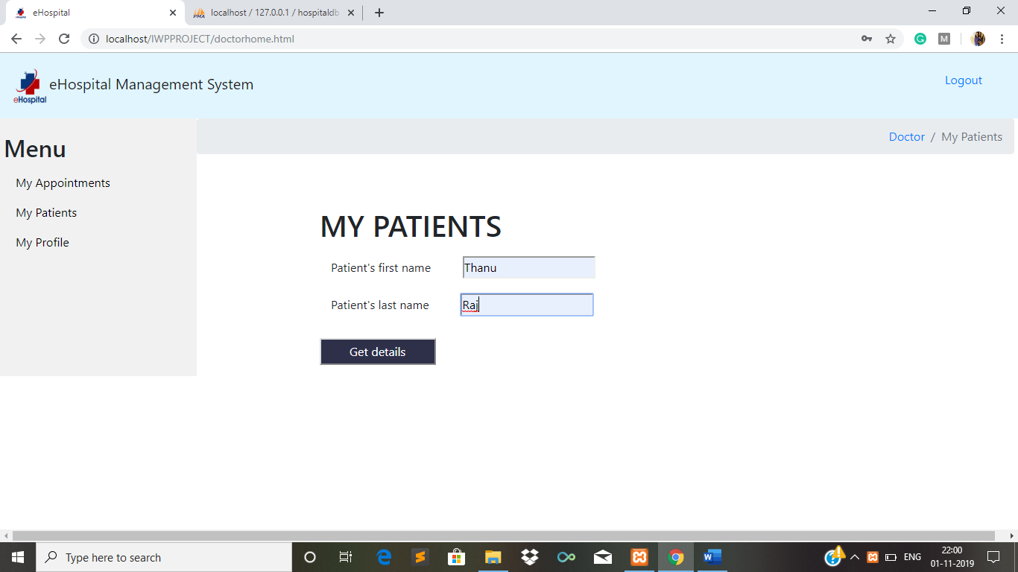

Figure 25: View his patients

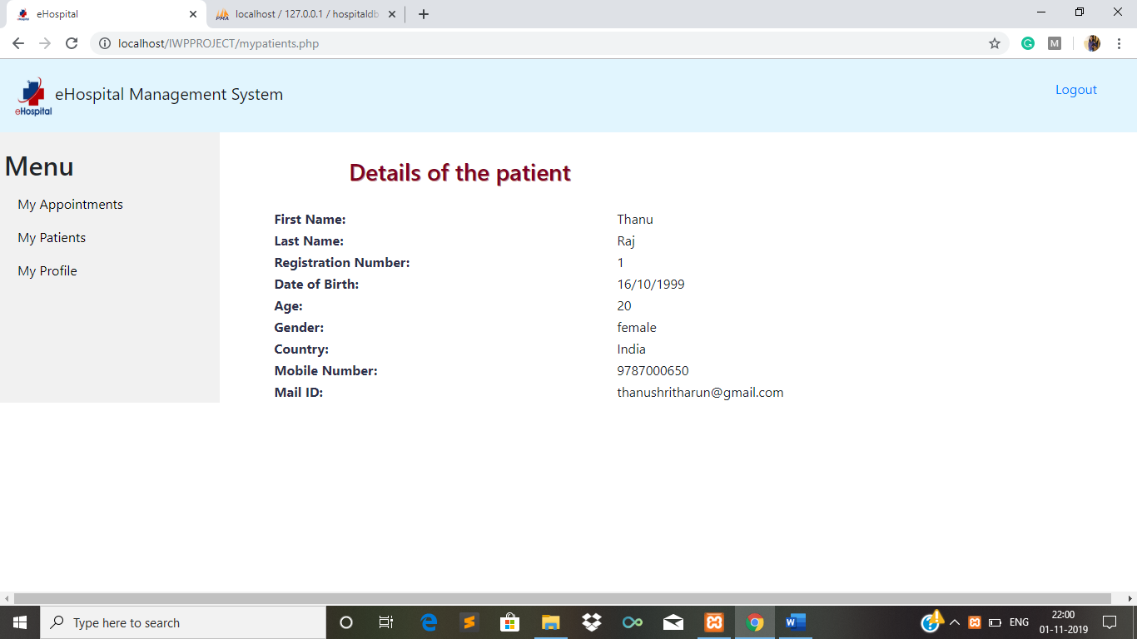

Figure 26: View his patient’s details

**4.5.5. Doctor profile**

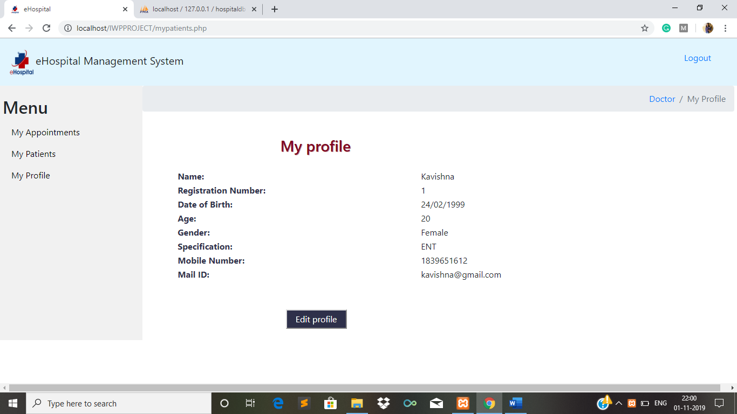

Figure 27: Doctor profile

**4.5.6. Doctor edit profile**

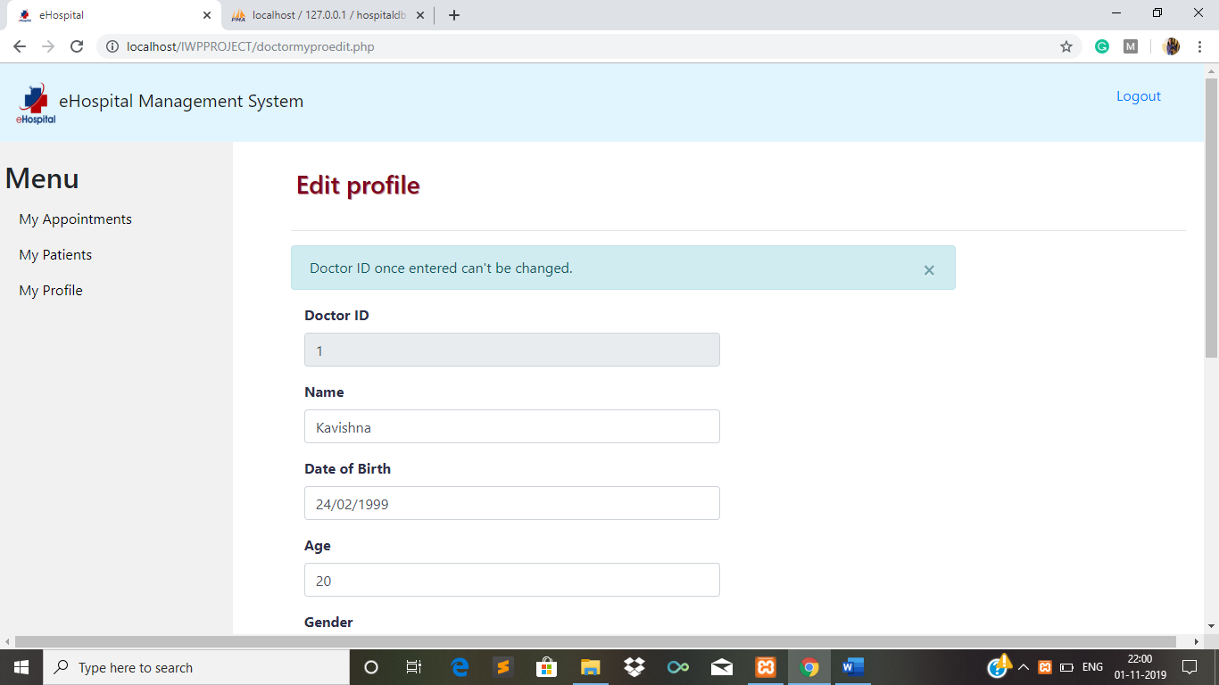

Figure 28: Doctor edit profile

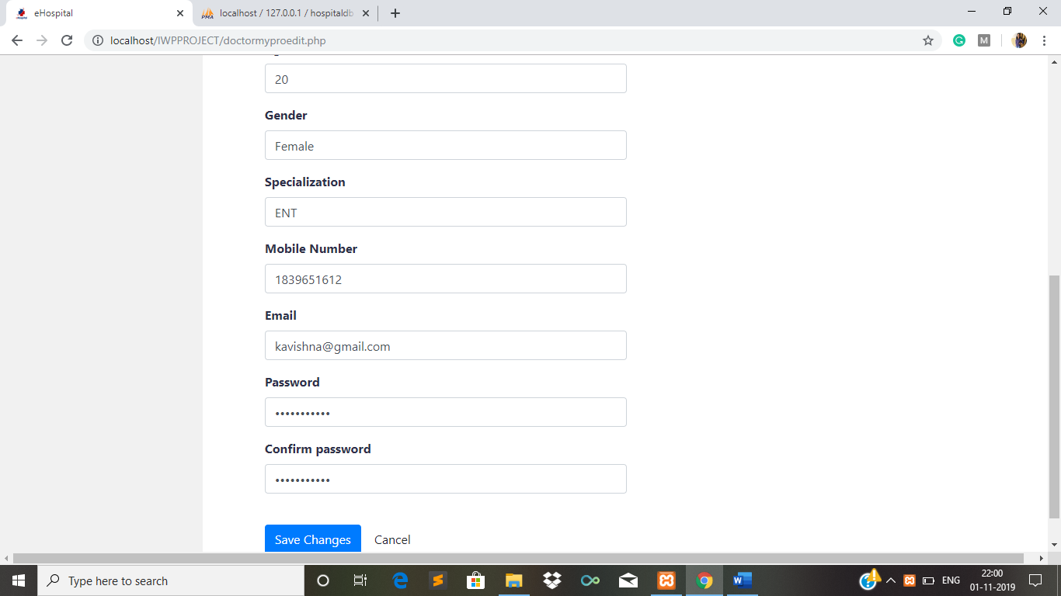

Figure 29: Doctor edit profile (scrolled down)

**4.5.7. Doctor sign up**

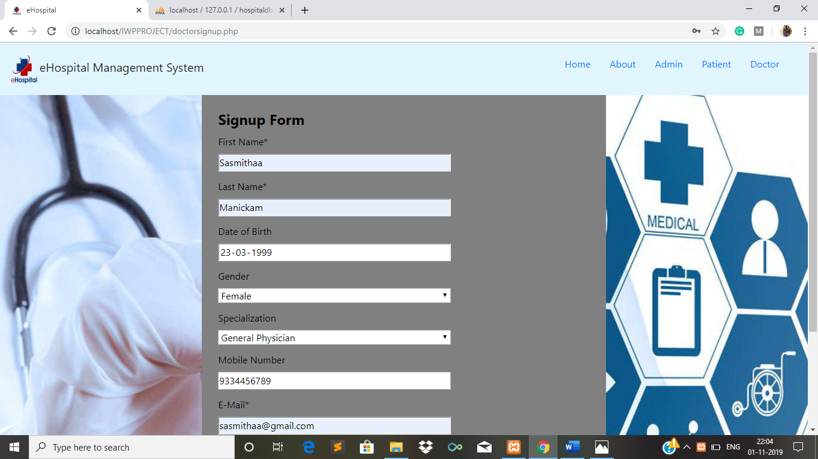

Figure 30: Doctor signup

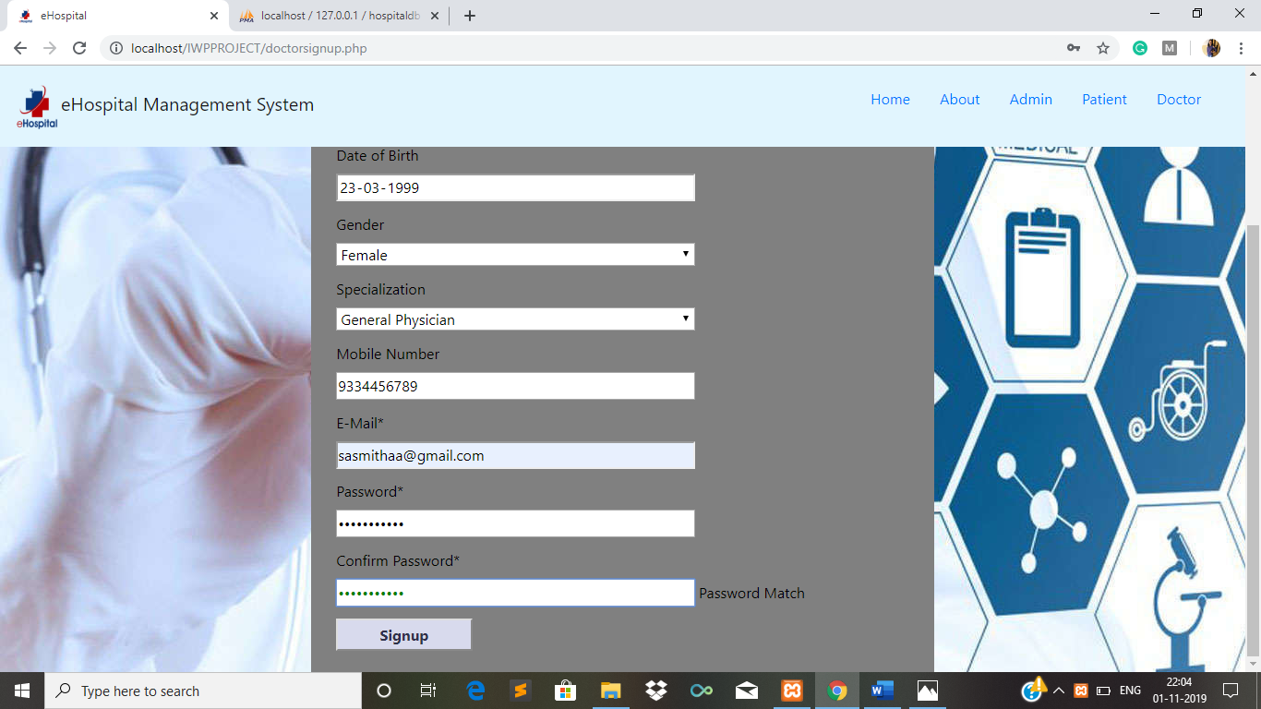

Figure 31: Doctor signup (Scrolled down)

**4.6. Admin Module**

**4.6.1. Admin login**

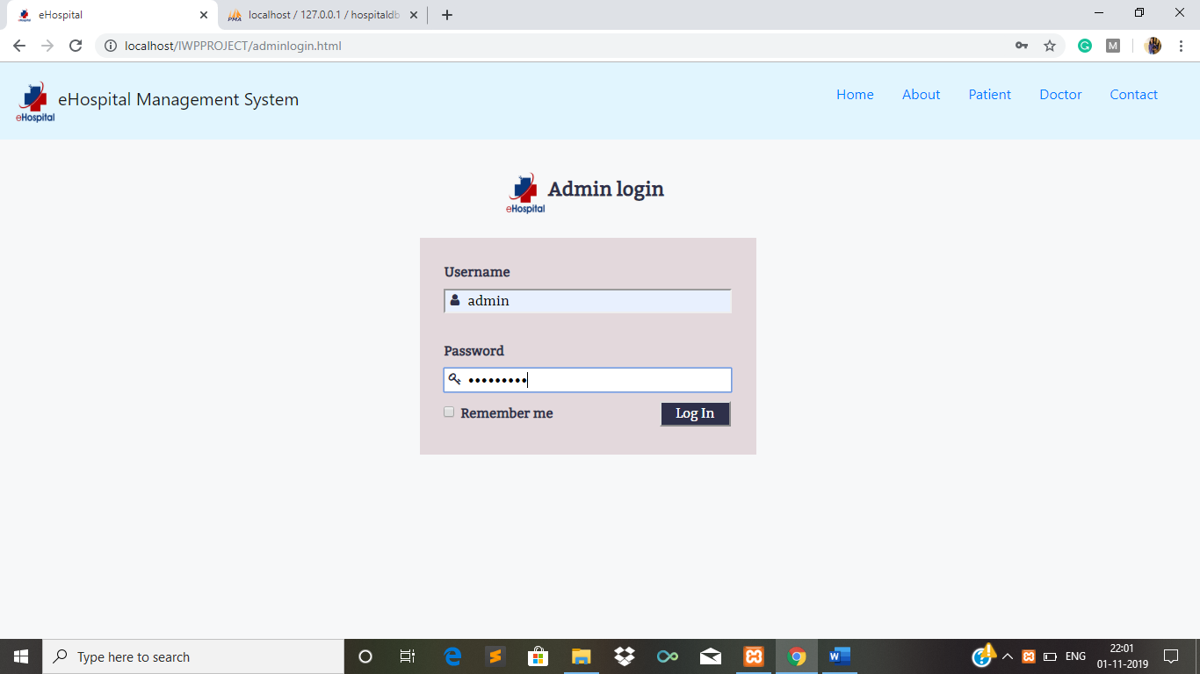

Figure 32: Admin login

**4.6.2. Admin home page**

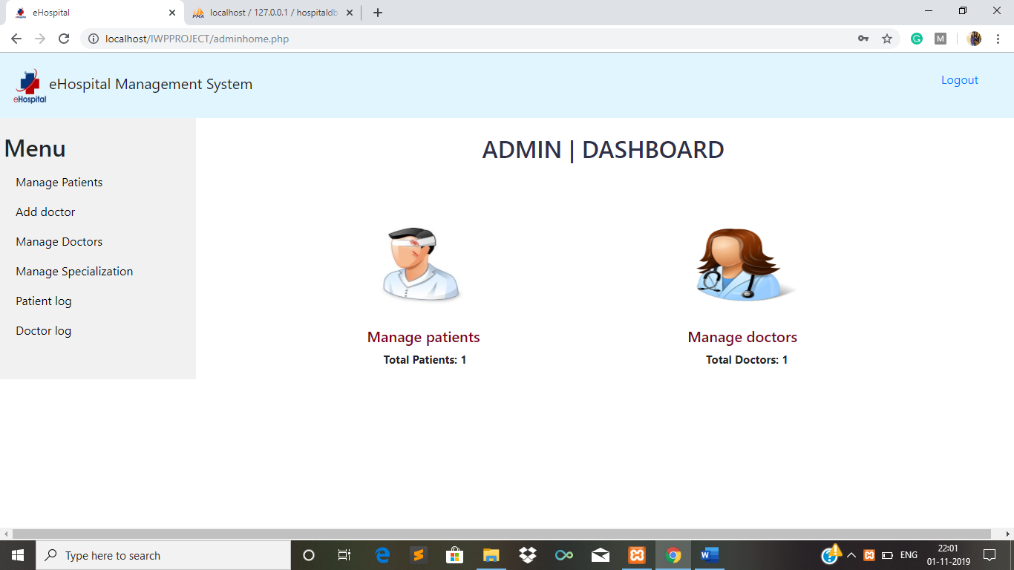

Figure 33: Admin home page

**4.6.3. Manage patients**

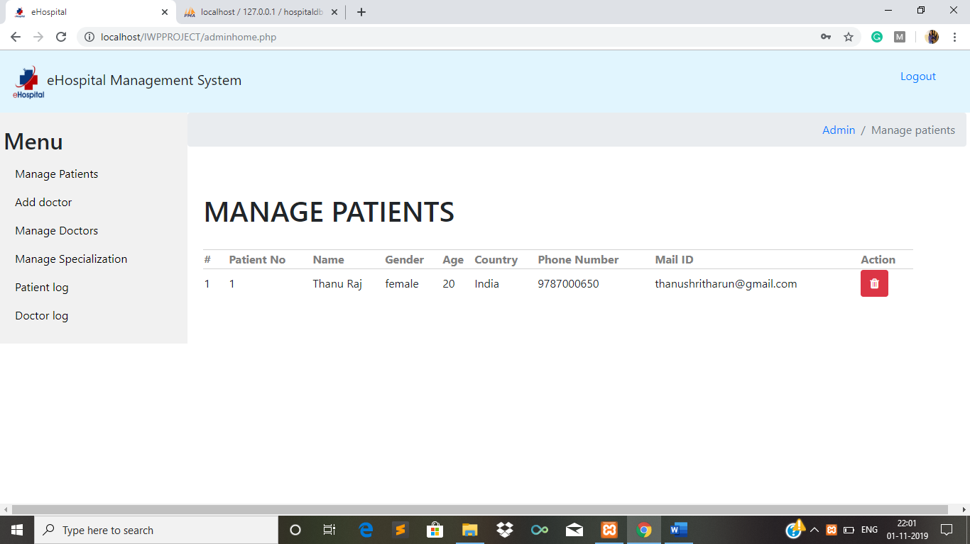

Figure 34: Manage patients

**4.6.4. Add doctor**

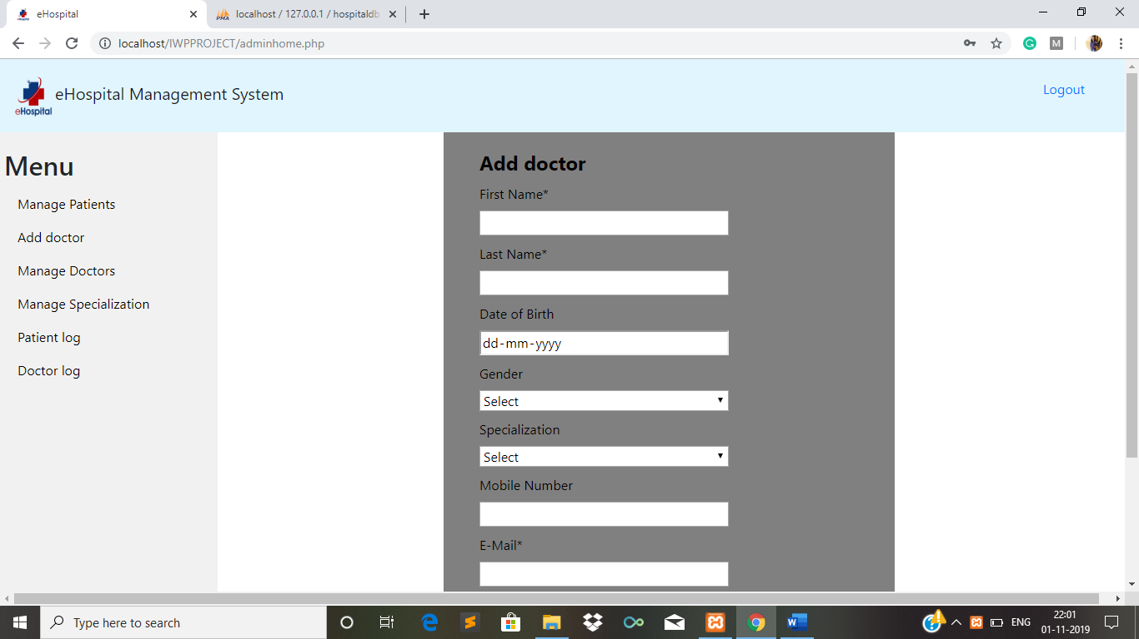

Figure 35: Add doctor

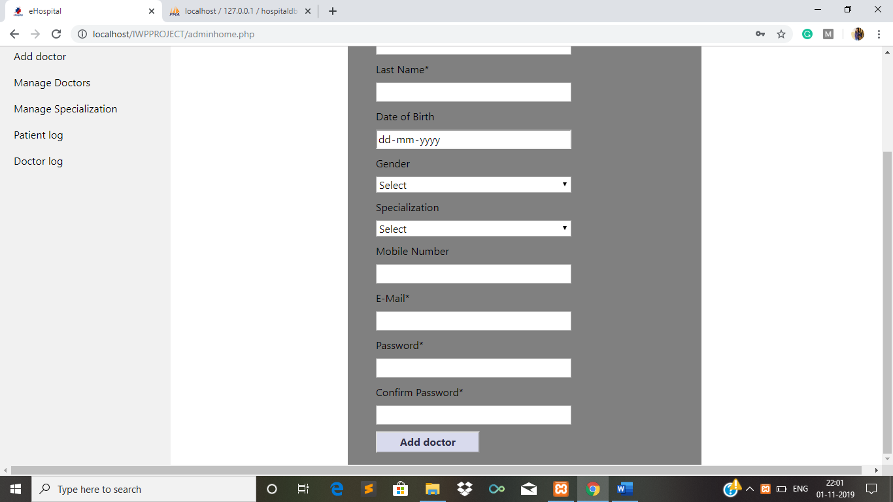

Figure 36: Add doctor (Scrolled down)

**4.6.5. Manage doctors**

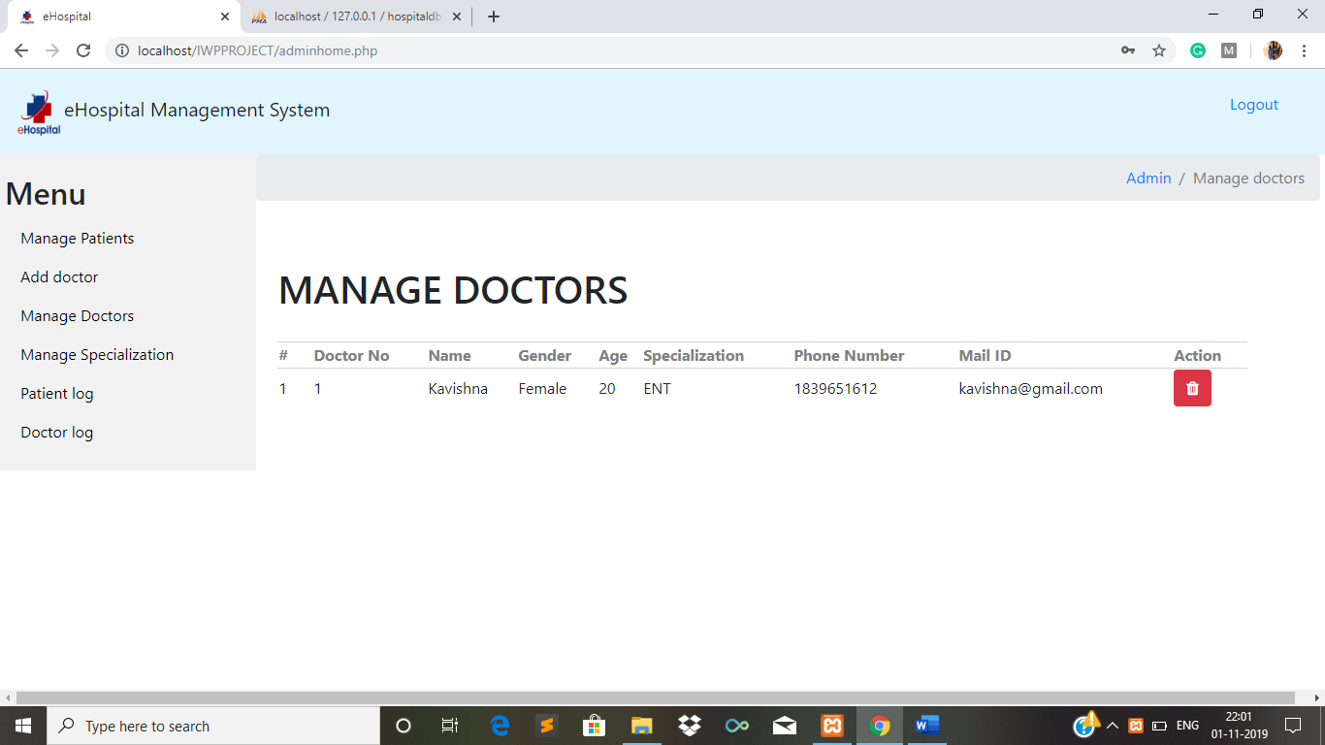

Figure 37: Manage doctors

**4.6.6. Manage specialization**

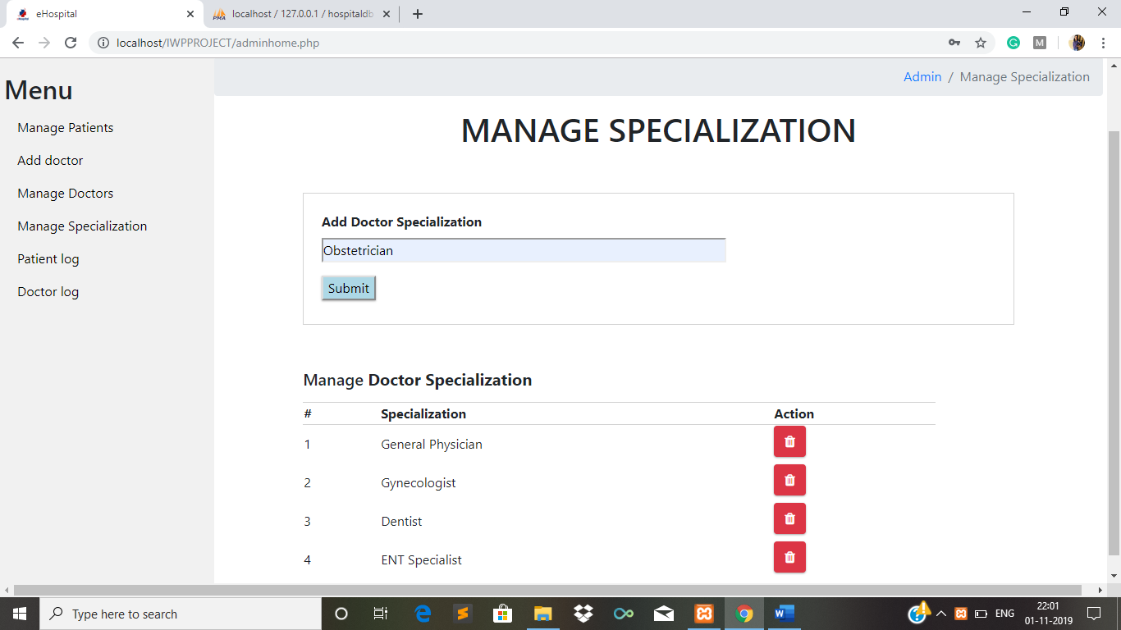

Figure 38: Manage specialization

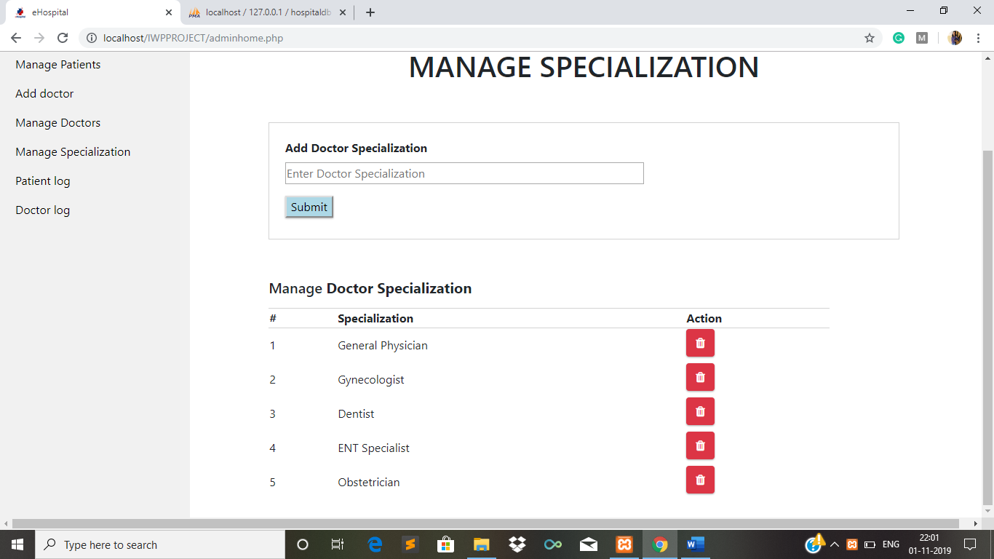

Figure 39: Manage specialization after adding a new one

**5.Conclusion**

The hospital management system is an inevitable part of the lifecycle of the modern medical institution. It automates numerous daily operations and enables smooth interactions of the users. Developing the hospital system software is a great opportunity to create the distinct, efficient and fast delivering healthcare model. Implementation of hospital management system project helps to store all the kinds of records, provide coordination and user communication, implement policies, improve day-to-day operations, arrange the supply chain, manage financial and human resources, and market hospital services. This beneficial decision covers the needs of the patients, staff and hospital authorities and simplifies their interactions. It has become the usual approach to manage the hospital. Many clinics have already experienced its advantages and continue developing new hospital management system project modules. The package was designed in such a way that future modifications can be done easily.

The following conclusions can be deduced from the development of this project:

* Automation of entire system improves efficiency
* It provides friendly graphical user interface which proves to be better when compared to existing system.
* Gives appropriate access to authorized users depending on their permissions
* It effectively overcomes the delay in communication
* Updating of information is so much easier
* System security and data security are other features
* The system has adequate scope for modification in future if necessary

**Compress your complete project code and installation guidelines for recent technologies(Software) as a single zip/rar file and upload in the below link. File name should be your Reg_No_Slot (Ex: 17BCE0001_L15_L16.zip) .**[**https://docs.google.com/forms/d/e/1FAIpQLSctHieP8jCycw4NYkyUslzhs0UoBzSdPebf5yVf0trJew9LLg/viewform?usp=pp_url**](https://docs.google.com/forms/d/e/1FAIpQLSctHieP8jCycw4NYkyUslzhs0UoBzSdPebf5yVf0trJew9LLg/viewform?usp=pp_url)